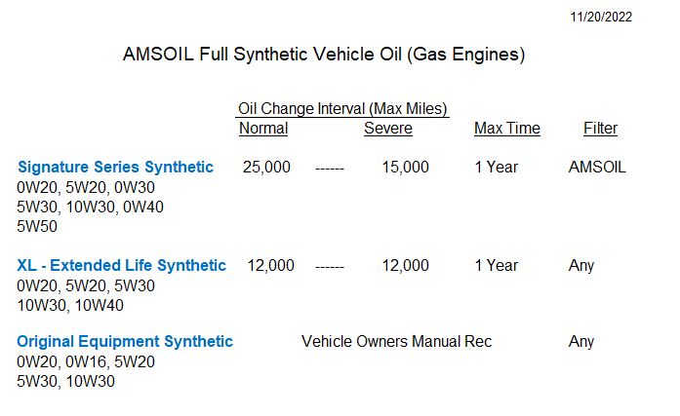

AMSOIL Recommended Oil Change Intervals
For Mechanically Sound Vehicles

Normal Service: (1 Yr / 25,000 or 35,000 miles, with AMSOIL Oil Filter) ** Intervals vary based on type AMSOIL used.

Personal transportation vehicles frequently traveling
greater than 10 miles at a time and not operating under
Severe Service.

Severe Service: (1 Yr / 15,000 or 17,500 miles, with AMSOIL Oil Filter) ** Intervals vary based on type AMSOIL used.

Turbo Charged Engines

Commercial or fleet vehicles

Excessive engine idling.

Vehicles with greater than 100,000 miles

Daily short trips of less than 10 miles

Frequent towing, plowing or hauling heavy loads.

Frequent driving in dusty conditions

EAO Oil Filters: 1 Yr or 25,000 miles when used with AMSOIL

EA15 Oil Filters: 1 Yr or 15,000 miles when used with AMSOIL

